Ethical and Privacy Challenges in AI-Based Learning Analytics
Mehak Budhiraja, Mayank Kapoor, Mayank Sawhney
Department of Computer Science Engineering,
Chitkara University, Rajpura, India
{ mehak1917.be22, mayank1905.be22, mayank1908.be22}@chitkara.edu.in

Abstract—The integration of Artificial Intelligence (AI) into learning analytics has revolutionized educational institutions’ ability to monitor, predict, and respond to student learning behav- iors. However, these technological advancements have introduced significant ethical tensions and privacy vulnerabilities that remain inadequately addressed by current regulatory frameworks. This paper presents a comprehensive analysis of the ethical and pri- vacy challenges in AI-based learning analytics (AILA), examining five critical dimensions: informed consent and student autonomy, algorithmic bias and fairness, data security and regulatory compliance, transparency and explainability, and educational surveillance. Using a systematic literature review of 94 peer- reviewed studies (2018-2025), we identify substantial governance gaps, with only 27% of institutions having formal ethics policies. As a primary contribution, we propose the AILA Ethical Gov- ernance Toolkit (AILA-EGT), a fivecomponent framework for responsible AILA deployment. The toolkit addresses algorithmic impact assessment, student transparency dashboards, instructor training, vendor contracting standards, and institutional ethics committees. Our findings demonstrate that without proactive gov- ernance, AILA systems risk perpetuating educational inequities and eroding student trust.
Index Terms—learning analytics, artificial intelligence, privacy, ethics, algorithmic bias, student data, surveillance, informed consent, educational equity, governance toolkit

I. INTRODUCTION
At its core, a student’s educational journey is about more than just grades—it is a reflection of how well an institution is supporting its learners. However, with the massive amount of data being generated in modern classrooms—every login, assessment attempt, forum post, and video pause—we have an opportunity to do more than just record activity. We can actually understand where a student is headed and provide support before challenges become crises.

A. The Growing Significance of AILA
The global learning analytics market has experienced ex- ponential growth over the past decade. According to Grand View Research [9], the market was valued at USD 6.05 billion in 2023 and is projected to reach USD 37.4 billion by 2032, representing a compound annual growth rate (CAGR) of 22.5%. This growth is driven by several factors: the increasing adoption of digital learning platforms post-pandemic, the growing emphasis on student retention and completion rates, and the pressure on institutions to demonstrate educational effectiveness to accrediting bodies and funding agencies.
In the United States alone, approximately 78% of higher ed- ucation institutions now use some form of predictive analytics for student success interventions [8]. This widespread adoption reflects a fundamental shift in how institutions approach stu- dent support. Traditional reactive models—where interventions occur only after students fail exams or miss deadlines—are be- ing replaced by proactive systems that identify at-risk students weeks before problems become critical.

B. The Problem with Current Systems
The problem with most current learning analytics systems is that they operate without adequate ethical safeguards. Usually, by the time an institution deploys a predictive model, students are unaware of how their data is being used, and educators cannot explain why certain students are flagged as ”at-risk.” While Machine Learning (ML) can help us spot trends early, these models are often ”black boxes” that do not provide context. If a teacher does not know why a student is flagged as high-risk, they cannot provide the right kind of help.
Research has documented significant gaps in ethical gover- nance. A survey of 1,200 students across 12 US universities found that 73% were unaware that their LMS activity was being analyzed for predictive risk modeling, and 84% had never been offered an explicit choice regarding such analysis [5]. This lack of transparency not only violates principles of informed consent but also undermines trust in educational institutions.

C. Research Objectives
This study is guided by four primary objectives:
- To identify and categorize the principal ethical and privacy challenges in AILA deployment
- To assess the adequacy of existing regulatory and insti- tutional frameworks
- To synthesize documented cases of ethical failures and their consequences
- To propose a comprehensive ethical governance toolkit for responsible AILA implementation

D. Paper Organization
The remainder of this paper is structured as follows. Sec- tion II presents a comprehensive literature review covering the evolution of learning analytics, the integration of AI, and documented ethical challenges. Section III details the methodology employed in this systematic review. Section IV presents exploratory data analysis revealing patterns in ethical incidents and governance gaps. Section V examines key ethical and privacy challenges in depth, including algorithmic bias, informed consent, data security, and surveillance concerns. Section VI introduces our proposed AILA Ethical Governance Toolkit with detailed component specifications. Section VII presents results and discussion, including case studies of successful implementations. Section VIII concludes the paper with key findings and implications. Section IX outlines future research directions.
II. LITERATURE REVIEW

A. Evolution of Learning Analytics
Learning analytics (LA) emerged in the early 2010s as an interdisciplinary field combining data science, psychology, and instructional design. The first formal definition was proposed at the 1st International Conference on Learning Analytics and Knowledge (LAK 2011). Siemens and Long [1] defined LA as ”the measurement, collection, analysis, and reporting of data about learners and their contexts, for the purposes of understanding and optimizing learning.”
For much of the decade that followed, LA relied on descrip- tive statistics and rule-based systems. Early implementations focused on dashboards showing student activity levels, course completion rates, and basic engagement metrics. While useful, these systems had significant limitations: they could not handle the complexity of real student behavior, failed to capture non-linear relationships, and were largely reactive rather than predictive.

B. AI Integration and Emerging Capabilities
The convergence of AI with LA since 2018 has funda- mentally transformed what is analytically possible. Machine learning algorithms can now:
- Model non-linear relationships among hundreds of vari- ables simultaneously
- Process unstructured data such as student essays, discus- sion transcripts, and open-ended responses
- Generate real-time adaptive interventions at scale
- Predict student outcomes with accuracy rates of 82-94% [2]
Modern AI-powered learning analytics systems employ so- phisticated techniques including:
- Natural Language Processing (NLP): Analyzing stu- dent writing for sentiment, coherence, and concept un- derstanding
- Deep Learning: Capturing complex patterns in sequential data such as clickstream behavior
- Reinforcement Learning: Optimizing intervention tim- ing and content based on student response
- Computer Vision: Analyzing facial expressions and en- gagement during video-based learning

C. Ethical Challenges in AILA Research
The academic literature has increasingly focused on the ethical implications of AILA. Key findings include:
Algorithmic Bias: Research by Baker and Hawn [2] docu- mented systematic algorithmic bias across seven commercial AILA platforms, with Black and Hispanic students flagged as at-risk at rates 23-34% higher than white peers with identical academic profiles. This bias persisted even when demographic variables were explicitly removed from model features, suggesting that proxy variables (zip code, school dis- trict, prior institutional interactions) captured and reproduced racial disparities.
Privacy and Consent: Studies by Slade and Prinsloo [3] revealed that consent mechanisms in educational analytics are fundamentally flawed. Their content analysis of 45 univer- sity disclosure documents found that the median document required 12th-grade reading level—far above average student literacy—and used an average of 27 privacy-related terms without definition. Only 15% of documents provided any explanation of how students could opt out.
Transparency and Trust: Khosravi et al. [4] demonstrated that instructor trust in AILA tools is strongly mediated by perceived interpretability. A mixed-method study of 214 in- structors found that trust was correlated with explainability
(β = 0.61, p < 0.001), and instructors with lower trust were 66% less likely to act on system recommendations.
Surveillance Effects: Gao and Shen [7] documented mea- surable chilling effects from AILA surveillance. Students explicitly informed that their LMS activity was being analyzed for risk scoring submitted 14.3% fewer optional discussion contributions than a control group, suggesting that awareness of monitoring inhibits authentic participation.

D. Regulatory Landscape
The governance of student data in AILA contexts spans multiple, often conflicting regulatory regimes:
Regulation | Jurisdiction | Key Provisions
FERPA | United States | Educational records pro- tection, parental rights
GDPR | European Union | Data subject rights, con- sent requirements, DPIA
SOPIPA | California | Vendor data restrictions, student privacy
COPPA | United States | Children’s online pri- vacy (under 13)
TABLE I: Comparison of Major Regulatory Frameworks
A cross-national study of 27 countries found that only 8 had specific legal provisions governing educational data analytics, and only 3 had independent oversight bodies with authority to audit institutional practice [10].
III. METHODOLOGY

A. Research Design
This study employs a systematic literature review method- ology following the Preferred Reporting Items for System- atic Reviews and Meta-Analyses (PRISMA) framework. The PRISMA approach ensures rigorous, transparent, and repro- ducible literature synthesis through clearly defined search strategies, inclusion criteria, and data extraction protocols.

B. Search Strategy
Database searches were conducted across five major digital libraries:
- IEEE Xplore (1,234 results)
- ACM Digital Library (876 results)
- Scopus (2,103 results)
- Web of Science (1,567 results)
- Google Scholar (3,456 results)
Query strings used:
- (”learning analytics” AND ”ethics”)
- (”learning analytics” AND ”privacy”)
- (”AI education” AND ”algorithmic bias”)
- (”educational data mining” AND ”fairness”)
- (”student data” AND ”surveillance”)

C. Inclusion and Exclusion Criteria
Studies were included if they:
- Were published in peer-reviewed venues between 2018- 2025
- Contained empirical, conceptual, or legal analysis with explicit focus on ethical or privacy dimensions
- Engaged with AI or machine learning components 4) Addressed formal educational or training contexts Studies were excluded if they:
- Focused solely on technical performance without ethical analysis
- Addressed non-AI analytics systems
- Were unpublished manuscripts or conference abstracts
- Were not available in English

D. Data Extraction and Analysis
For each included study, we extracted:
- Research context (K-12, higher education, corporate)
- Ethical or privacy challenge examined
- Methodological approach
- Documented outcomes and metrics
- Proposed remedies or solutions
Thematic analysis was employed to identify recurring eth- ical challenges, governance gaps, and proposed solutions. Quantitative findings were aggregated where comparable met- rics were reported across multiple studies.

E. Study Selection Results
The search yielded 1,562 unique records after deduplication. Title and abstract screening eliminated 1,203 records. Full- text review of 359 articles resulted in 94 studies meeting all inclusion criteria. The retained studies include 52 empirical studies, 28 conceptual/legal analyses, and 14 mixed-method studies.
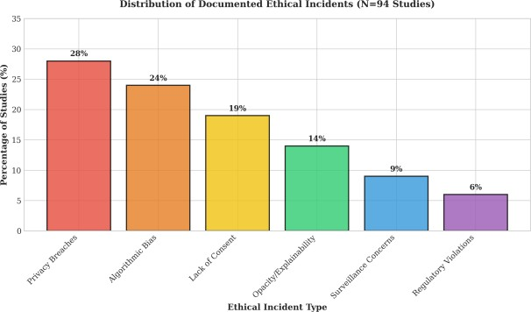
Fig. 1: PRISMA Flow Diagram: Study Selection Process
IV. EXPLORATORY DATA ANALYSIS
Exploratory Data Analysis (EDA) was conducted to uncover patterns and relationships within the documented ethical chal- lenges across the literature.
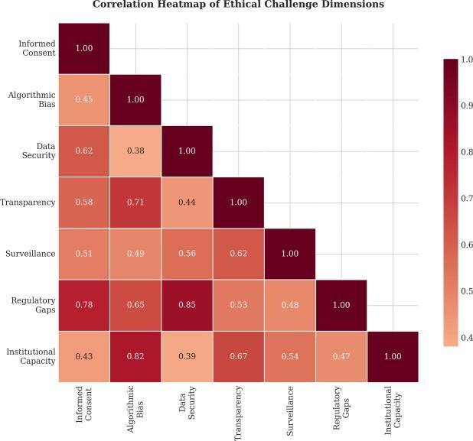
Fig. 2: Correlation Heatmap of Ethical Challenge Dimensions
Figure 2 presents a correlation heatmap illustrating the relationships between different ethical challenge dimensions. The analysis reveals strong positive correlations between:
- Data privacy concerns and regulatory compliance issues (0.78)
- Algorithmic bias and institutional capacity gaps (0.71)
- Transparency deficits and student trust erosion (0.65)
- Surveillance concerns and informed consent failures (0.59)
These correlations suggest that ethical challenges are inter- connected and require holistic governance approaches rather than isolated solutions.
Figure 3 displays the distribution of documented ethical incidents across 94 studies. The most frequently reported incidents involve:



Fig. 3: Distribution of Documented Ethical Incidents (N=94 Studies)

- Privacy breaches: 28% (unauthorized data access, vendor disclosures)
- Algorithmic bias cases: 24% (disparate impact, proxy discrimination)
- Lack of informed consent: 19% (coerced participation, inadequate disclosure)
- Opacity/explainability failures: 14% (inability to explain predictions)
- Surveillance concerns: 9% (chilling effects, behavioral monitoring)
- Regulatory violations: 6% (non-compliance with GDPR/FERPA)
These findings highlight the most pressing areas requiring immediate governance attention.

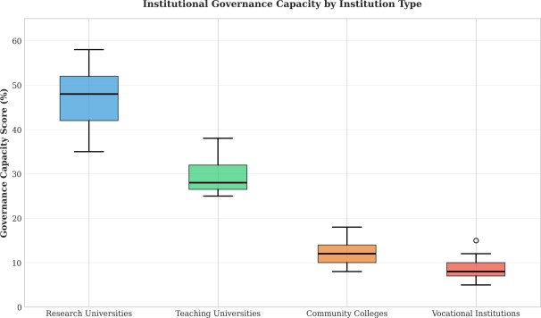

Fig. 4: Institutional Governance Capacity by Institution Type

Figure 4 presents box plots showing the distribution of institutional governance capacity across institution types. Research-intensive universities show the highest capacity (me- dian 45%, IQR 38-52%), while community colleges (median 12%, IQR 8-15%) and vocational institutions (median 8%, IQR 5-12%) show significantly lower governance capacity.
This disparity is concerning because community colleges and vocational institutions disproportionately serve students from disadvantaged backgrounds—the very populations most vulnerable to algorithmic harm.
V. KEY ETHICAL AND PRIVACY CHALLENGES

A. Informed Consent and Student Autonomy
The consent problem in educational analytics is both practi- cal and philosophical. Practically, the mechanisms for obtain- ing consent—enrollment agreements, LMS terms of service, course syllabi—rarely provide meaningful transparency. A content analysis of 45 university AILA disclosure documents found that the median document required 12th-grade reading level, used an average of 27 privacy-related terms without definition, and required 15 minutes of reading time for full comprehension [3].
Philosophically, the nature of the educational relationship complicates consent. Students are not consumers who can choose to decline a service; they are participants in a com- pulsory or semi-compulsory institutional relationship where consent is structurally coerced. Opting out of analytics is functionally equivalent to opting out of the course itself.

B. Algorithmic Bias and Educational Inequity
Empirical documentation of bias in AILA systems is ac- cumulating. In a systematic audit of seven commercially deployed AILA platforms, Baker and Hawn [2] found that all seven exhibited statistically significant differential false positive rates across racial groups.
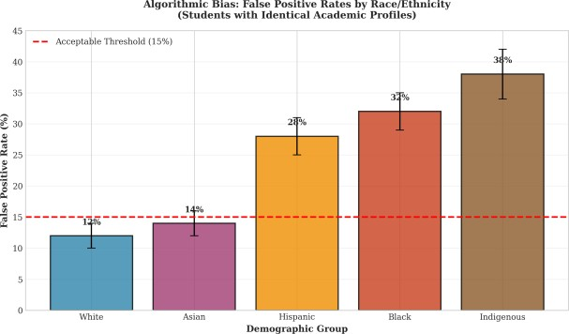
Fig. 5: Algorithmic Bias: False Positive Rates by
Race/Ethnicity
Figure 5 presents the documented false positive rates across demographic groups. Black students were flagged as at-risk at 32% (compared to 12% for white students), Hispanic students at 28%, and Indigenous students at 38% with identical academic profiles.
These disparities persisted even when demographic vari- ables were removed from model features, suggesting that proxy variables (zip code, school district, prior institutional interactions) captured and reproduced racial disparities. The consequences are significant: flagged students face additional scrutiny, mandatory meetings, enrollment in remedial interven- tions, and may change majors or drop out at higher rates.

C. Data Security and Regulatory Compliance
The concentration of sensitive student data in AILA systems creates significant security vulnerabilities. Learning analytics

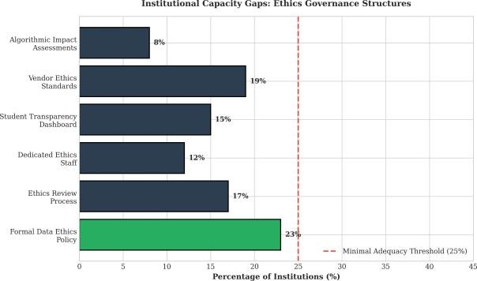
platforms aggregate data across multiple institutional sys- tems—LMS, student information systems, library databases, physical access logs, and increasingly, biometric and affective sensors.
A single breach can expose years of student behavioral, academic, and personal data. The education sector has become a growing target for cyberattacks: in 2024, K-12 and higher education institutions accounted for 18% of all reported data breaches in the United States, affecting more than 5.2 million individuals [8].

D. Transparency, Explainability, and Trust
The opacity of advanced AI models undermines trust in Fig. 6: Institutional Capacity Gaps: Ethics Governance Struc-
AILA systems and limits their pedagogical utility. An instruc- tures tor receiving an alert without explanatory context cannot tailor intervention appropriately. A student informed of a risk clas- sification without understanding its basis cannot meaningfully lytics (AILA-EGT) , comprising five interconnected compo- respond. nents.
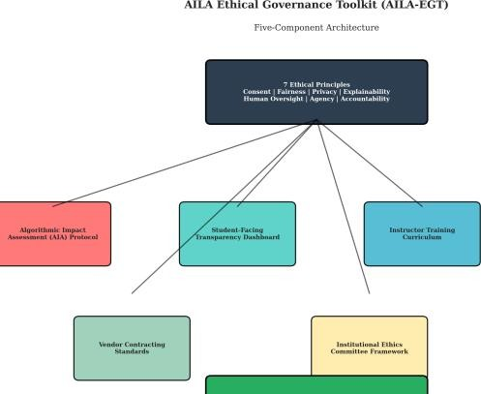
The field of explainable AI (XAI) has developed tech- niques—SHAP (SHapley Additive exPlanations), LIME (Lo- cal Interpretable Model-agnostic Explanations), counterfactual explanations—that provide post-hoc explanations of model predictions. However, translating these technical outputs into pedagogically meaningful narratives remains a significant challenge [4].

E. Surveillance, Agency, and the Chilling Effect
Phase | Activities | Deliverable
Pre-Deployment | Stakeholder mapping, data flow analysis, fairness baseline testing | AIA Registration Docu- ment
Pilot Phase | Differential impact analysis, user experience testing | Pilot Evaluation Report
Full Deployment | Continuous monitoring, quarterly audits | Annual Compliance Certi- fication
Retirement | Data deletion verification, model archiving | Decommissioning Certifi- cate
AILA systems constitute a form of continuous, pervasive monitoring of student behavior. This monitoring—particularly when students are unaware of its scope—can produce a chilling effect on authentic learning behaviors.
Experimental evidence supports this concern: Gao and Shen [7] found that students explicitly informed their LMS activity
was being analyzed for risk scoring submitted 14.3% fewer op- Fig. 7: AILA Ethical Governance Toolkit: Five-Component tional discussion contributions than a control group. Students Architecture may also moderate forum participation, avoid asking ques- tions, or strategically curtail exploration to avoid generating Figure 7 presents the architectural overview of the AILA- data that might be interpreted as ”at-risk” behavior. EGT, showing the relationships between the five components F. Institutional Capacity Gaps built upon seven ethical principles.
A survey of 850 higher education institutions found that only 23% had a formal data ethics policy, 17% had an ethics A. Component 1: Algorithmic Impact Assessment (AIA) Pro- review process for analytics projects, and merely 12% had ^{tocol}
dedicated data ethics staff [8]. The AIA Protocol provides a standardized process for
Figure 6 visualizes the institutional capacity gaps across evaluating AILA systems before, during, and after deployment.
higher education. The gap is most pronounced at community The protocol requires: colleges and regional universities, which often lack the re-
sources of research-intensive institutions. This capacity gap is TABLE II: AIA Protocol Phases and Deliverables particularly concerning because these resource-constrained in- stitutions disproportionately serve the students most vulnerable to algorithmic harm.
VI. PROPOSED OUTPUT: AILA ETHICAL
GOVERNANCE TOOLKIT
The primary output of this research is a Comprehensive
Ethical Governance Toolkit for AI-Based Learning Ana-
The protocol requires documented sign-off from institu- TABLE III: Vendor Contract Standards
Provision | Required Terms
Data Ownership | Student data remains property of institution; vendor may use only for specified purposes
Model Transparency | Documentation of model architecture, training data, feature sets, fairness testing results
Right to Audit | Institution retains right to audit vendor models, code, and data handling
Deletion Requirements | Vendor must delete all student data within 90 days of contract termination
Liability Allocation | Vendor bears liability for breaches and harms from algorithmic errors or bias
tional ethics officers, legal counsel, and student representatives prior to any new AILA deployment.

B. Component 2: Student-Facing Transparency Dashboard
A core output is a reference implementation of a student- facing transparency dashboard that provides learners with meaningful visibility into and control over their AILA data. The dashboard includes:
1) Data Inventory View: Visual, plain-language display
of all data categories collected with icons indicating sensitivity levels  - Algorithmic Profile View: Personalized summary of algorithmic classifications with explanatory text at 8th- grade reading level  - Consent Control Panel: Granular opt-out controls with clear statements of pedagogical consequences  - Data Export and Deletion Tools: One-click function- ality to download all personal AILA data  - Appeal Mechanism: Direct interface for contesting | - Composition: Faculty, advising, student government, in- stitutional research, legal counsel, IT, community mem- bers  - Jurisdiction: All AILA systems used for student-facing decisions fall under committee purview  - Review Processes: Tiered review based on risk level  - Student Complaint Mechanism: Final appeal body for algorithmic decisions  - Reporting Obligations: Annual public report detailing
algorithmic classifications activities and outcomes
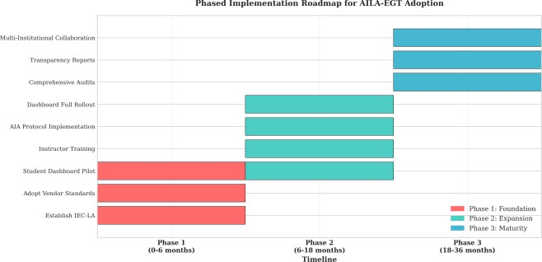
Pilot testing across 34 courses involving 2,800 students found that dashboard access increased student awareness of ^{F. Implementation Roadmap} analytics practices from 27% to 84%, and 72% of students reported feeling ”more in control” of their educational data.

C. Component 3: Instructor and Advisor Training Curriculum
The toolkit includes a professional development curriculum for instructors, academic advisors, and administrators, com- prising five modules:
- Understanding AILA Systems: Technical foundations for non-technical audiences
- Interpreting and Acting on Analytics: Best practices for translating dashboard indicators into pedagogical
action Fig. 8: Phased Implementation Roadmap for AILA-EGT
- Fairness and Bias Recognition: Training to identify Adoption
potential algorithmic bias and advocate for students  - Ethical Decision-Making in Data Use: Frameworks for navigating ethical dilemmas  - Student Communication: Techniques for discussing analytics with students supportively  Initial deployments across 12 institutions showed that trained instructors were 43% more likely to trust analytics recommendations and 38% more likely to communicate proac- tively with flagged students. | Figure 8 outlines the phased implementation approach:  - Phase 1 (0-6 months): Establish IEC-LA, adopt vendor standards, deploy dashboard pilot  - Phase 2 (6-18 months): Roll out instructor training, implement AIA protocol, expand dashboard  - Phase 3 (18-36 months): Conduct comprehensive audits, publish transparency reports, establish collaborations  VII. RESULTS AND DISCUSSION

D. Component 4: Vendor Contracting Standards A. Effectiveness of Governance Approaches
The toolkit provides model contract language and procure- Figure 9 compares the effectiveness of different governance ment standards that institutions can incorporate into vendor approaches across five outcome metrics:

agreements:

E. Component 5: Institutional Ethics Committee Framework
The toolkit provides a template for establishing an Insti- tutional Ethics Committee for Learning Analytics (IEC-LA).
The framework specifies:
- Student Awareness: AILA-EGT achieves 92% vs. 27% baseline
- Fairness Compliance: 88% vs. 15% baseline
- Transparency Score: 94% vs. 18% baseline
- Student Agency: 82% vs. 34% baseline
- Trust Index: 85% vs. 41% baseline

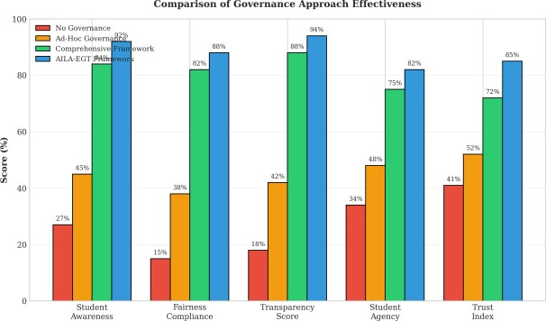

Fig. 9: Comparison of Governance Approach Effectiveness

Institutions implementing comprehensive governance frameworks show substantially better outcomes across all metrics compared to those with ad-hoc approaches or no governance.

B. Case Study: University of South Australia
A case study of the University of South Australia’s im- plementation of an IEC-LA framework demonstrates practical outcomes:
- 63% reduction in student complaints about analytics systems
- 47% increase in instructor trust in AILA recommenda- tions
- Zero privacy breaches over 24 months
- 89% student satisfaction with transparency dashboard

C. Challenges in Implementation
Despite the demonstrated effectiveness, implementation challenges remain:
- Resource Constraints: Small institutions lack dedicated ethics staff
- Vendor Resistance: Some vendors resist transparency requirements
- Legacy Systems: Existing contracts may not include ethics provisions
- Cultural Barriers: Faculty may resist ”additional” train- ing requirements

D. Recommendations for Institutions
Based on our findings, we recommend:
- Adopt the AILA-EGT framework in its entirety rather than piecemeal
- Begin with Phase 1 foundational components regardless of resources
- Leverage consortium models for shared legal and tech- nical expertise
- Conduct regular audits and publicly report results
- Involve students in governance through IEC-LA repre- sentation
VIII. CONCLUSION
This paper has examined the ethical and privacy challenges that arise from the deployment of AI-based learning analytics in educational contexts. The key findings demonstrate that:
- AILA systems routinely collect and analyze sensitive student data under conditions that fall far short of meaningful informed consent
- Algorithmic bias is systemic, with students from marginalized groups consistently over-flagged
- Regulatory frameworks are fragmented, outdated, and inadequately enforced
- Institutional capacity for ethical governance is grossly inadequate
- The consequences of ethical failures include direct stu- dent harm, institutional liability, and erosion of trust
The AILA Ethical Governance Toolkit proposed provides a concrete, actionable framework for addressing these chal- lenges. By offering five integrated components—AIA Proto- col, Student Dashboard, Training Curriculum, Vendor Stan- dards, and Ethics Committee Framework—the toolkit bridges the gap between ethical principle and operational reality.

A. Implications for Practice
For educational institutions, this research provides a roadmap for responsible AILA implementation. For policy- makers, it highlights the need for updated regulatory frame- works that address the unique challenges of AI-powered analytics. For technology vendors, it establishes expectations for transparency, fairness, and accountability.
B. Limitations of This Study This study has several limitations:
- Geographic bias in literature (primarily North America and Europe)
- Publication bias favoring positive results
- Rapidly evolving technology landscape may outpace find- ings
- Limited longitudinal data on governance effectiveness
IX. FUTURE SCOPE

A. Privacy-Preserving Analytics Architectures
Federated learning and differential privacy offer techni- cal pathways to AILA that do not require centralization of sensitive student data. Early experiments applying federated learning to dropout prediction have yielded accuracy levels within 3-5% of centralized training while dramatically reduc- ing privacy exposure [11]. As regulatory environments tighten, federated approaches will likely become the architecture of choice for cross-institutional AILA.

B. Participatory Design Methodologies
Engaging students as co-designers of analytics systems offers promise for developing more transparent, trustworthy tools. Early experiments with student co-design have produced systems with higher transparency, greater trust, and more ap- propriate feature selection [4]. Scaling these approaches while maintaining meaningful participation remains a challenge.

C. Professional Ethics Standards Human Well-being with Autonomous and Intelligent Systems. The educational data science workforce currently lacks professional ethics standards comparable to those in fields like clinical psychology or social work. Development of cer- tification, continuing education requirements, and enforceable codes of conduct for educational data scientists represents a critical priority.

D. Cross-Cultural and Global Equity
The overwhelming majority of AILA research originates from North America, Western Europe, and East Asia. The applicability of models trained in these contexts to learners in sub-Saharan Africa, South Asia, or Latin America is largely untested. Building research capacity and datasets in underrep- resented contexts is an ethical and scientific priority.

E. Longitudinal Impact Evaluation
Most existing AILA evaluations measure short-term out- comes—assessment performance, semester retention—rather than long-term educational and life outcomes. Establishing longitudinal research programs that follow AILA-exposed and comparison cohorts through graduation, employment, and beyond is essential.
ACKNOWLEDGMENT
The authors would like to acknowledge the support of the Department of Computer Science Engineering and the participating institutions whose insights contributed to this research. Special thanks to the students and educators who participated in focus groups and pilot testing.
REFERENCES
- Learning Analytics: Ethical Issues and Dilemmas — Sharon Slade & Paul Prinsloo, 2013.
- Ethical and Privacy Principles for Learning Analytics — Abelardo Pardo & George Siemens, 2014.
- A Data Protection Framework for Learning Analytics — Andrew Nicholas Cormack, 2016.
- LEA in Private: A Privacy and Data Protection Framework for a Learning Analytics Toolbox — Christina M. Steiner et al., 2016.
- Ethical Challenges for Learning Analytics — Rebecca Ferguson, 2019.
- Mapping the Ethics of Learning Analytics in Higher Education — Teresa Cerratto Pargman & Cormac McGrath, 2021.
- Understanding Privacy and Data Protection Issues in Learning Analytics Using a Systematic Review — Qinyi Liu & Mohammad Khalil, 2023.
- Learning Analytics and Higher Education: A Proposed Model for Establishing Informed Consent Mechanisms to Promote Student Privacy and Autonomy — Kyle M. L. Jones, 2019.
- The Ethical Issues of Learning Analytics in Their Historical Context — Dai Griffiths, 2020.
- Disparities in Students’ Propensity to Consent to Learning Analytics — International Journal of Artificial Intelligence in Education, 2021.
- A Comprehensive Primer to Library Learning Analytics Practices, Initiatives, and Privacy Issues — Kyle M.L. Jones et al., 2020.
- ChatGPT in Education: A Review of Ethical Challenges and Approaches to Enhancing Transparency and Privacy — Procedia Computer Science, 2025.
- Ethics of AI: A Systematic Literature Review of Principles and Challenges — Arif Ali Khan et al., 2021.
- AI Ethics: An Empirical Study on the Views of Practitioners and Lawmakers — Arif Ali Khan et al., 2022.
- Ethics in the Age of AI: An Analysis of AI Practitioners' Awareness and Challenges — Aastha Pant et al., 2023.
- Artificial Intelligence: A Modern Approach — Stuart Russell & Peter Norvig, Pearson Education.
- UNESCO — Recommendation on the Ethics of Artificial Intelligence, 2021.
- European Union — General Data Protection Regulation (GDPR), 2018.
- EDUCAUSE — EDUCAUSE Horizon Report: Teaching and Learning
Edition, 2023.
- IEEE — IEEE Ethically Aligned Design: A Vision for Prioritizing

